COMMENTS ON
“PROPOSED ELEMENTS FOR THE POLITICAL DECLARATION OF WSSD”
Submitted by A SEED JAPAN

We at A SEED JAPAN, (Action for Solidarity, Equality, Environment and Development) , an international environmental youth NGO, call upon the following to be included in the political declaration of WSSD.

7. We recognize that globalization has added a new dimension to the pursuit of sustainable development. While it offers new opportunities for sustainable development, the benefits and costs of globalization are very unevenly distributed. Hence, the continuing relevance of the principle of common but differentiated responsibility. We commit ourselves to making globalization equitable and inclusive. To this end, we will take concrete measures to create an enabling environment, promote good governance at all levels, including democratic values and the rule of law, and promote the concept and effective implementation of corporate accountability and enhance international cooperation.

11. we underline the need to ensure that a trade system should contribute to sustainable development, support the right of developing countries to protect and promote their domestic agricultural sectors from the viewpoint of food security.

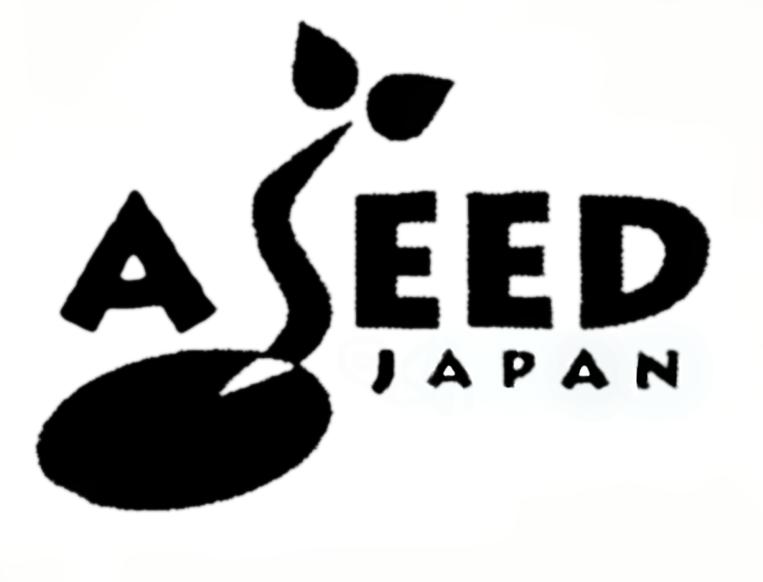
A SEED JAPAN
5-4-23 Shinjuku, Shinjyku 160-0022
Tel：+81-3-5366-7484 Fax：+81-3-3341-6030
Email：asj@jca.apc.org URL：www.aseed.org

